Anne Riley  Author  and  Developer of the  Ideasphere Theory | 
SUGGESTED SPEECH TOPICS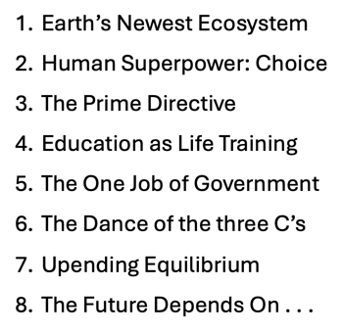 |   Contact:  Email: anne.riley.pgw@gmail.com  Phone: 503-313-9047  Website: https://www.thehumanidea.com

  - Biography
Armed with a stellar academic record, a degree in Accounting and an MBA, Anne Riley pursued a meaningful life in the business world. After years in various industries including chicken processing, high tech manufacturing, database design, elementary level teaching, system development, product distribution, private banking and writing, she realized that meaning is not easy to find. Of course, she was looking in the wrong place. Undeterred and influenced by Michael Rothschild's Bionomics as well as the works of Charles Darwin, Stephen J. Gould, and countless other famous scientists, she used her experiences to develop a theory known as the Ideasphere. The Ideasphere is an extension of the natural ecosystem but has its foundation in human ideas. The theory is articulated in the Socratic novel DINA: Nature's Case for Democracy and a non-fiction book The Human Idea, Earth's Newest Ecosystem.

